2022 Fall After School Registration Form 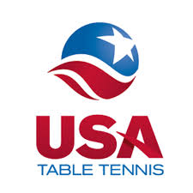

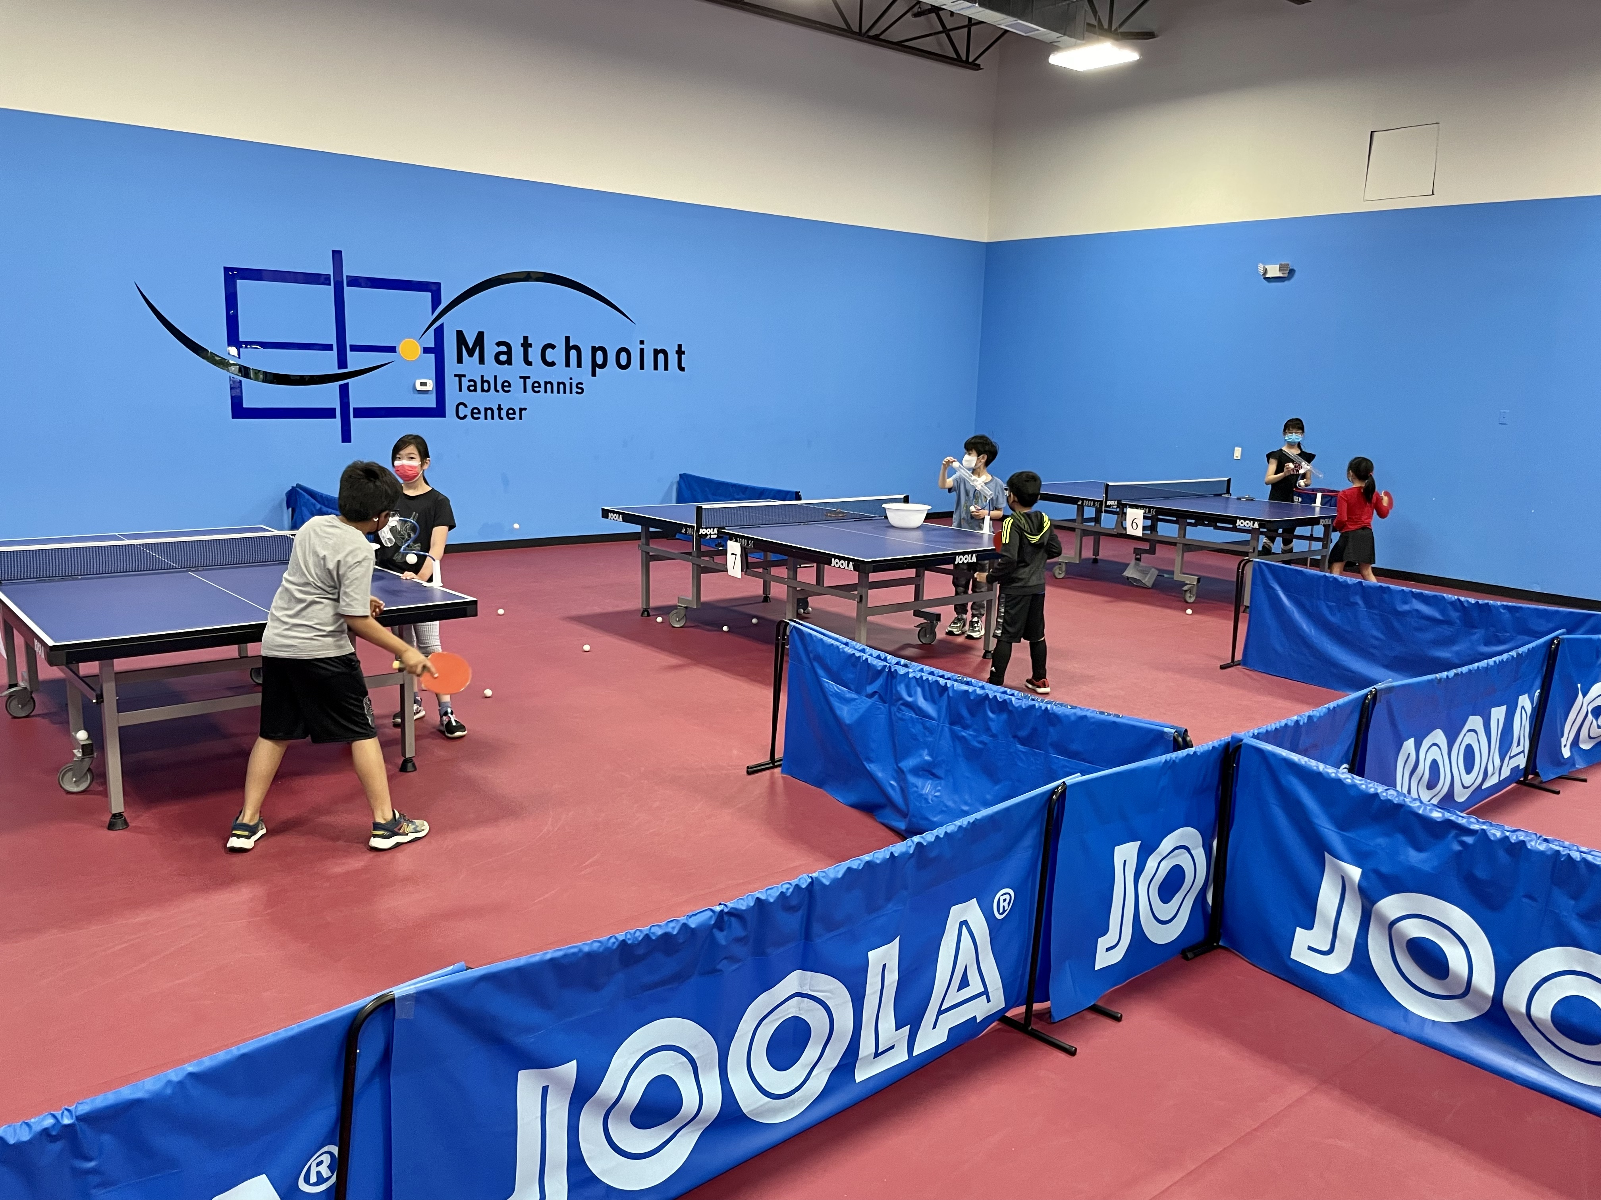
From 12th Sept.. to 21st Dec. 2022; Monday and Wednesday.

Matchpoint runs two-day training sessions from 4:30 pm - 6:00 pm during regular school weeks. Coaches hold practice sessions with the group.

Parents drop in: Before 4:25 pm
Training Time: 4:30 pm to 6:00 pm
Parents pick up: 6:00 pm to 6:30 pm

Training includes basic strokes and footwork and serve and receive skills.
*Pick up is non-available due to the safety concerns during Covid time.

□ Monday | □ Wednesday | □ Both

 | 1days/Week | 2 days/Week
MPTTC members | $500 (15 lessons) | $900 (30 lessons)
Non-members | $600 (15 lessons) | $1150 (30 lessons)
Drop in classes: | MPTTC-members  $40/class | Non-members  $50/class
*Member price only applies to annual members.

Student name: Gender: Age: Grade:

Home Address: City: Zip:

Parents name: Phone:

Email: Allergies:

Signature (Parents/Guardian): Date
RELEASE OF LIABILITY FOR PARTICIPANTS IN MATCHPOINT TABLE TENNIS CENTER AFTER SCHOOL TABLE TENNIS/PING PONG PROGRAM

PLEASE READ BEFORE SIGNING
The undersigned understands and voluntarily agrees that in CONSIDERATION OF ___________________________________, my child/ward, being allowed to participate in the Matchpoint Table Tennis Center after-school table tennis/ping pong program HEREBY RELEASE AND HOLD HARMLESS Matchpoint Table Tennis Center, its directors, officers, officials, agents, employees, volunteers, other participants, sponsoring agencies, sponsors, advertisers (Releasees), and if applicable, owners and lessors of premises - used to conduct the after school table tennis/pong pong program, WITH RESPECT TO ANY AND ALL INJURY, DISABILITY, DEATH, or loss or damage to person or property incident to my child’s involvement or participation in the after school program, WHETHER ARISING FROM THE NEGLIGENCE OF THE RELEASEES OR OTHERWISE, to the fullest extent permitted by law.
- I, for myself, my spouse, my child, and on behalf of my/our heirs, assigns, personal representatives and next of kin, HEREBY INDEMNIFY AND HOLD HARMLESS all the above Releasees from any and all liabilities incident to my child’s/ward’s involvement or participation in these programs, EVEN IF ARISING FROM THEIR NEGLIGENCE, to the fullest extent permitted by law.
- I HEREBY ASSUME FULL RESPONSIBILTY FOR AND RISK OF BODILY INJURY, DEATH OR PROPERTY DAMAGE to my child/ward due to the negligence or releases or otherwise while in, or about or upon the premises, and during transportation to and from the premises of Matchpoint Table Tennis Center and/or while using the premises or any facilities or the use of any equipment and the sudden or unforeseen malfunctioning of this equipment, and Matchpoint Table Tennis Center’s instruction, training, or supervision during the after school program.
- I understand that Matchpoint Table Tennis Center is not responsible for personal property lost or stolen while my child/ward is being transported to Matchpoint Table Tennis Center and while attending the after school table tennis/ping pong program.
I HAVE READ THIS RELEASE OF LIABILITY AND ASSUMPTION OF RISK AGREEMENT, FULLY UNDERSTAND ITS TERMS, UNDERSTAND THAT WE HAVE GIVEN UP SUBSTANTIAL RIGHTS BY SIGNING IT, AND SIGN IT FREELY AND VOLUNTARILY WITHOUT ANY INDUCEMENT.

___________________________________ _________________________________
(PARENT/GUARDIAN SIGNATURE) (PRINT NAME)
Date Signed: ___________________________________

