2022 Spring break Camp Registration Form

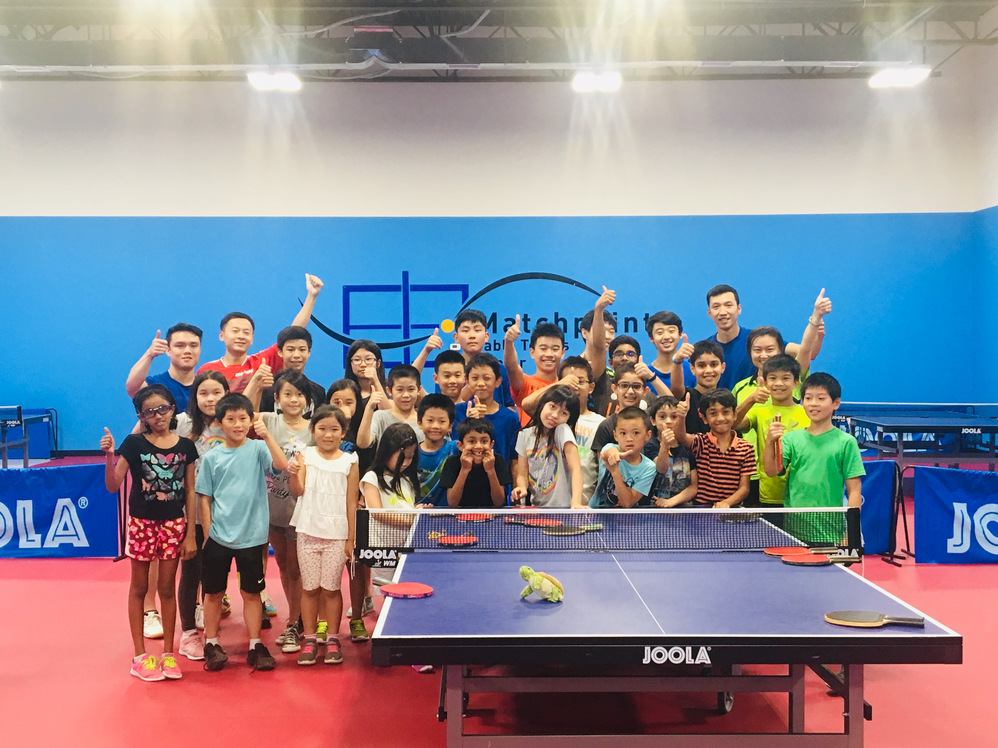
Camp Open Hours & Schedule
From 18th April to 22nd April; Monday to Friday

Morning Session: 9:00 AM-11:30 PM
Afternoon Session: 2:00 PM-4:30 PM
Full Day Session: 9:00 AM-4:30 PM

Note: Students should wear sports apparels and bring their own lunches (if register in full day session). Centre may provide paddles if needed.
Fees | MPTTC Member | Non-member
Half-day | $50 | $55
Daily | $80 | $90
Half-day Weekly | $225 | $250
Weekly | $375 | $425

Student name: Gender: Age:

Address: City: Zip:

Parents name: Phone:

Email: Allergies:

Signature (Parents/Guardian): Date:

