2020 Summer Camp Registration Form

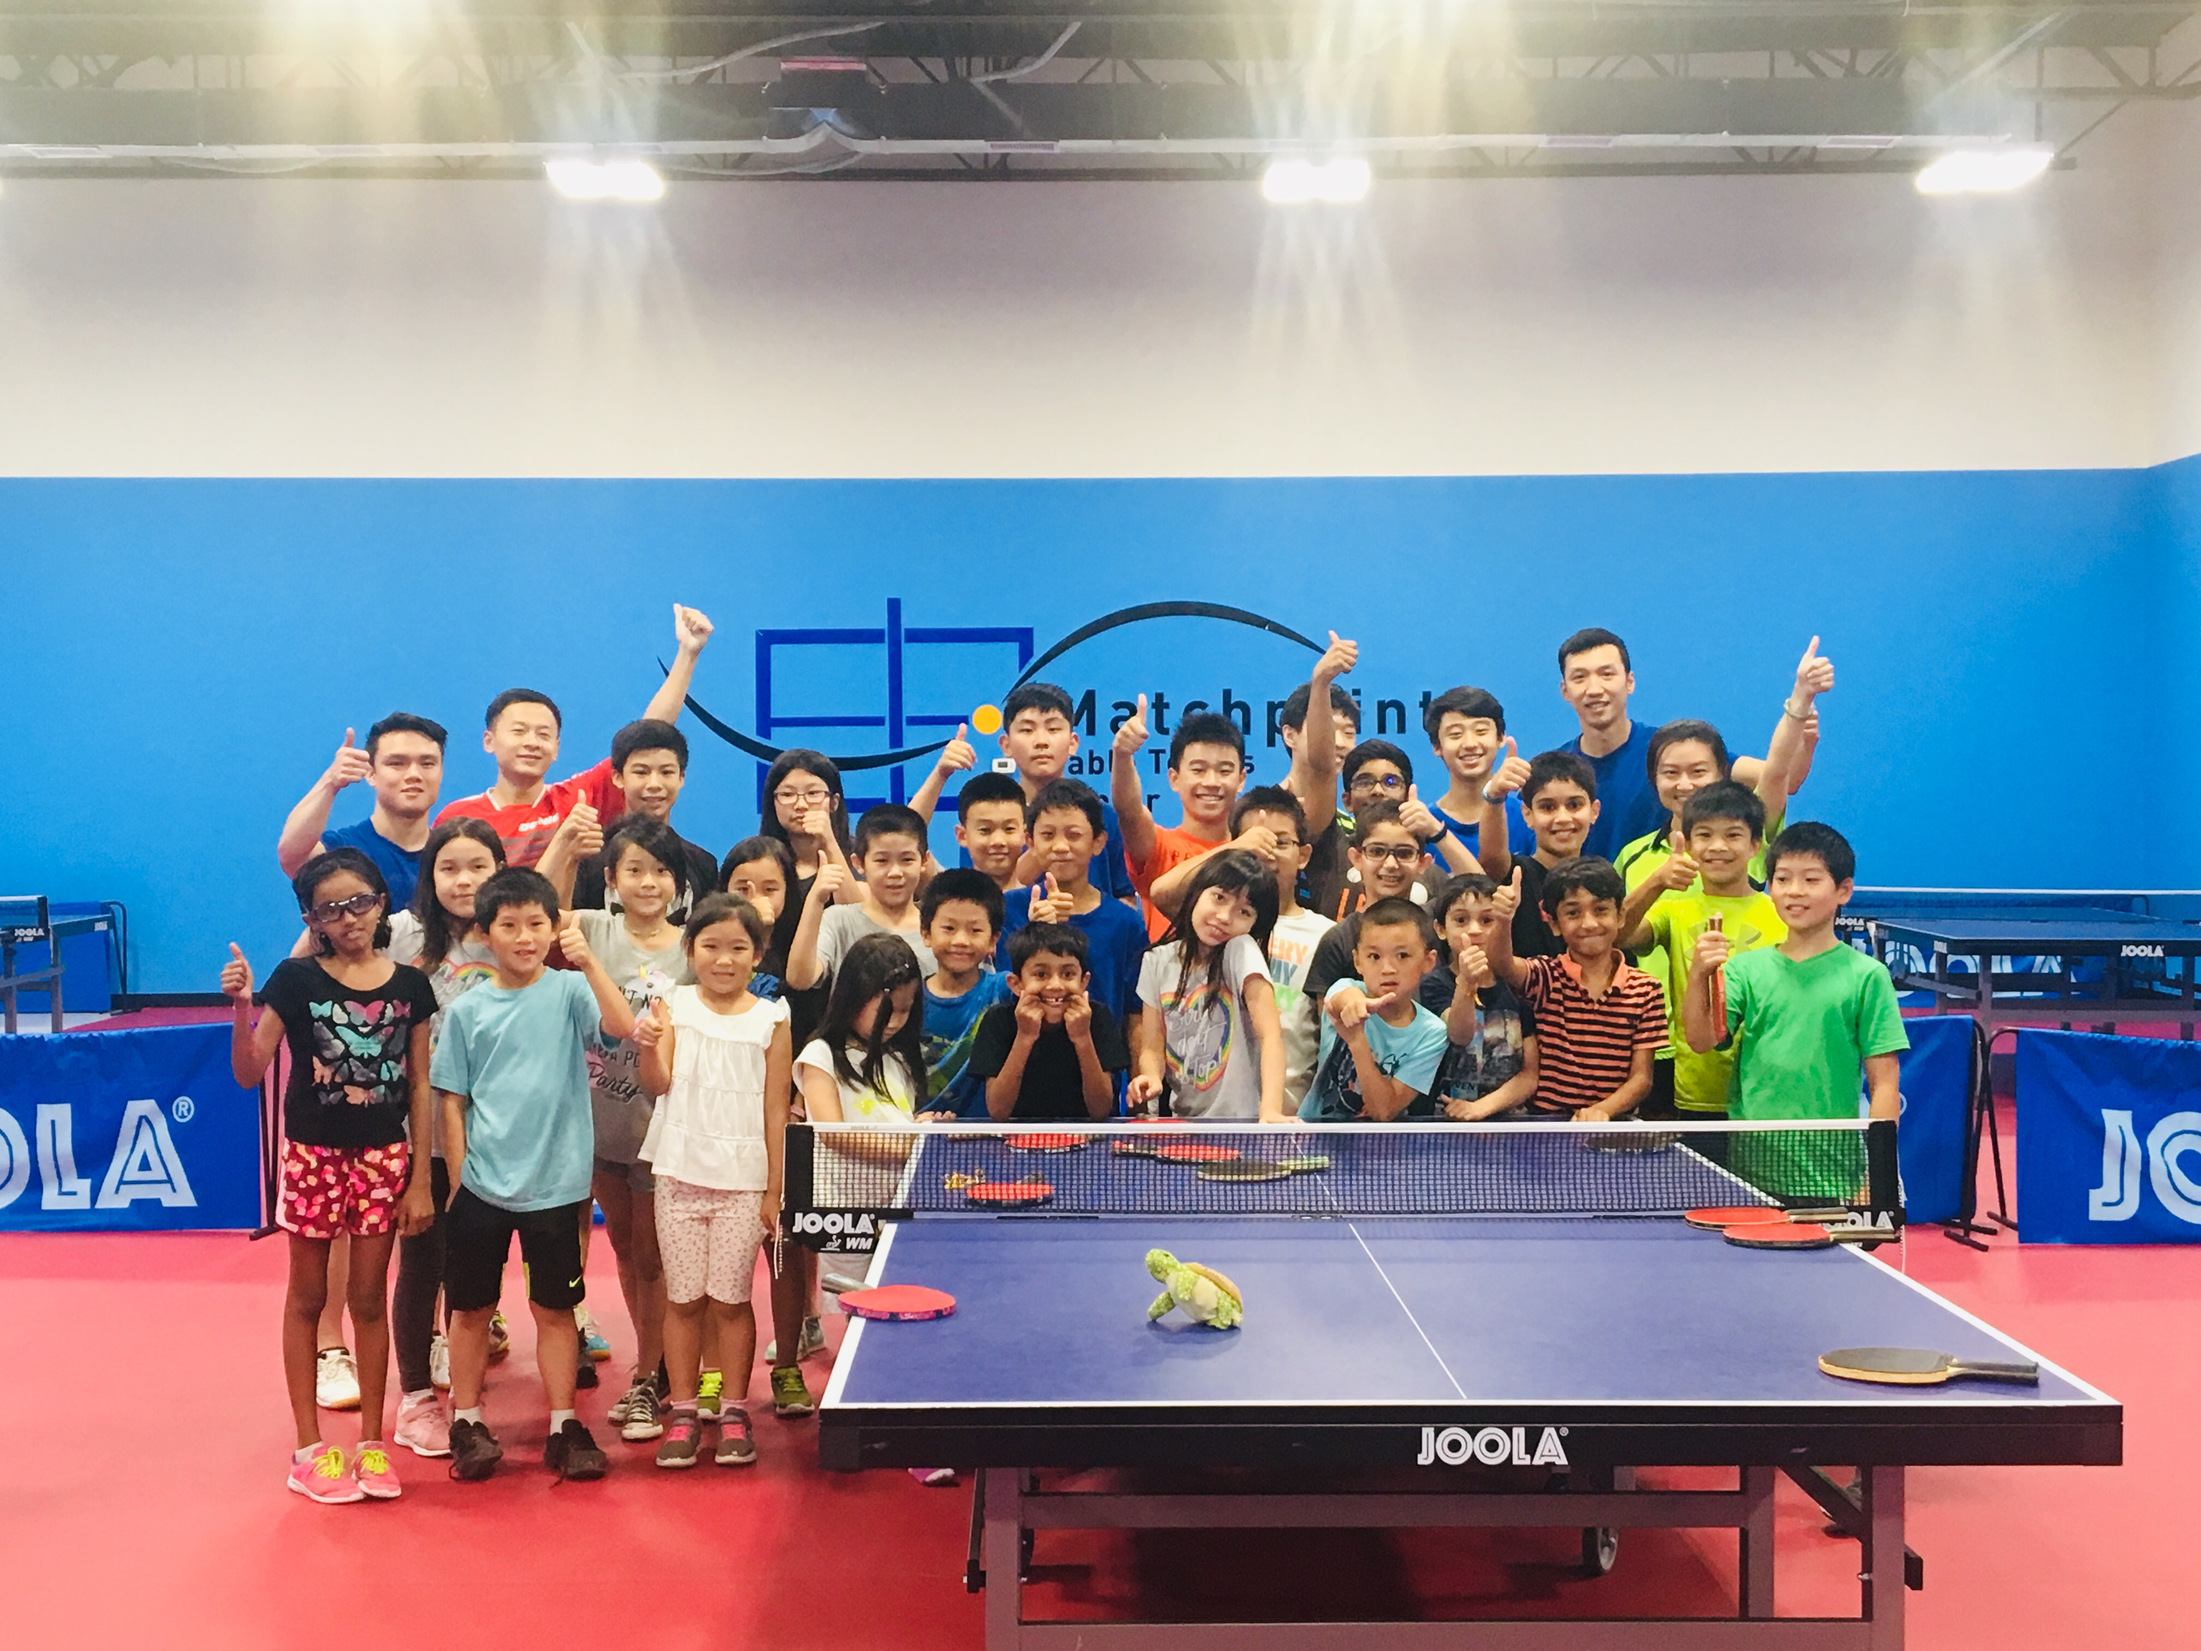
Summer Camp Open Hours & Schedules
Eight Weeks
From 6th July to 28th August; Monday to Friday

Morning Session Only
Parents drop off: 8:30 am to 9:00 am
Morning training: 9:00 am to 11:30 pm
Parents Pick up: 11:30 am to 12:00 pm

Note: Students should bring their own blades, water bottles and towels (if needed). Parents could also purchase blades and equipment from us.
Fees | MPTTC Member | Non-member
Weekly | $200 | $225
4 Weeks or more | $180 per week | $200 per week
Please make payments through Venmo or checks payable to: Matchpoint Table Tennis Center and mail (if pay by checks) to: 9 Whippany Road, Building A1, Unit 1A, Whippany, NJ 07981.

Please check the box below to choose which week or weeks students want to enroll in.
1st Week : July 6 - July 10 | 2nd Week : July 13 - July 17
3rd Week : July 20 - July 24 | 4th Week : July 27 - July 31
5th Week : August 3 - August 7 | 6th Week: August 10 - August 14
7th Week: August 17 - August 21 | 8th Week: August 24 - August 28

Student name: Gender: Age:

Address: City: Zip:

Parents name: Phone:

Email: Allergies:

Signature (Parents/Guardian): Date:

